Report No.:
IEC or ISO Standard Reference Number ATTACHMENT
Clause | Requirement + Test |  | Result - Remark | Verdict

ATTACHMENT TO TEST REPORT

IEC 62133-2:2017
(Republic of Korea) NATIONAL DIFFERENCES
(Secondary cells and batteries containing alkaline or other non-acid electrolytes - Safety requirements for portable sealed secondary lithium cells, and for batteries made from them, for use in portable applications - Part 2: Lithium systems)
Differences according to : |  | National standard KC62133(2020-07)
TRF template used: : |  | IECEE OD-2020-F3, Ed. 1.1
Attachment Form No. : |  | KR_ND_IEC62133_2A
Attachment Originator : |  | KTR
Master Attachment : |  | Dated 2020-08-06
Copyright © 2020 IEC System for Conformity Testing and Certification of Electrical Equipment (IECEE), Geneva, Switzerland. All rights reserved.
 | National Differences
7.3.6 | Over-charging of battery
(Revision) | [Add the bolded text]  b) Test  The test shall be carried out in an ambient temperature of 20 °C ± 5 °C. Each test battery shall be discharged at a constant current of 0,2 It A, to a final discharge voltage specified by the manufacturer. Sample batteries shall then be charged at a constant current of 2,0 It A, using a supply voltage which is:  • 1,4 times the upper limit charging voltage presented in Table A.1 (but not to exceed 6,0 V) for single cell/cell block batteries or  • 1,2 times the upper limit charging voltage presented in Table A.1 per cell for series connected multi-cell batteries, and  • sufficient to maintain a current of 2,0 It A throughout the duration of the test or until the supply voltage is reached.  • In case the charging voltage specified by the manufacturer is higher than the overcharge test voltage, the maximum charging voltage specified by manufacturer should be applied with 2.0 ItA,  (e.g., quick charging power bank, etc.)
[Replace to the following statement]
c) Acceptance criteria
Overcharging exceeding to the limits specified by the manufacturer should not result in fire or explosion.
Annex D | Definition for shape and materials of outer case for cell |  |  | —
(Addition) | D.1 General  Annex D provides definitions for shape and materials of outer case for cell  D.2 Shape of outer case for cell  D2.1 Cylindrical cell  Cell with a cylindrical shape in which the overall height is equal to or greater than diameter.  D2.2 Prismatic cell  Cell having the shape of a parallelepiped whose faces are rectangular  D.3 Materials of outer case for cell  D.3.1 Soft case  Non-metallic outer case or container for cell  D.3.2 Hard case  Metallic outer case or container for cell. |  | (Shape of outer cases)  Cylindrical  Prismatic  (Materials of outer cases)  Hard  Soft | —
Annex E | Calculation method of the volumetric energy density for cell |  |  | —
(Addition) | Annex E provide a calculation method of the volumetric energy density for cell in use of smart phone, tablet, notebook.  E.1 General  Unless otherwise stated in the Annex E, the dimensions for calculation are based on these for cell before shipment and the volumetric energy density shall be calculated with a maximum values specified by manufacturer. If the specification for cell can’t be provided a dimension for calculation, the manufacturer’s other documentation shall be provided to demonstrate compliance for its calculation. |  | Wh / L | —
 | E.2 Calculation Method  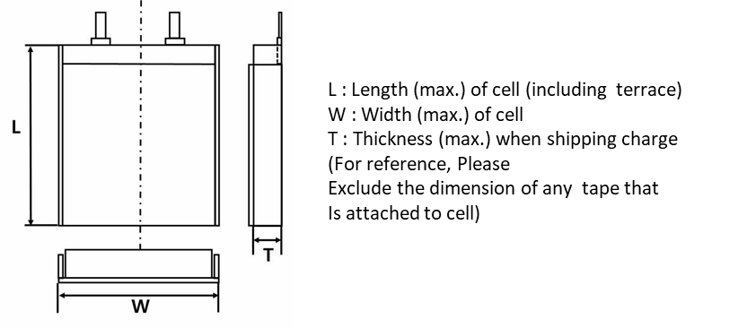  [E.1 – Prismatic cell using soft case]  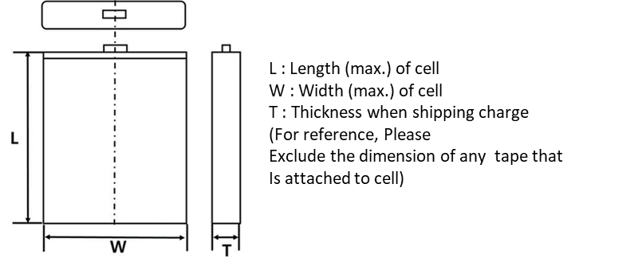  [E.2 – Prismatic cell using hard case]  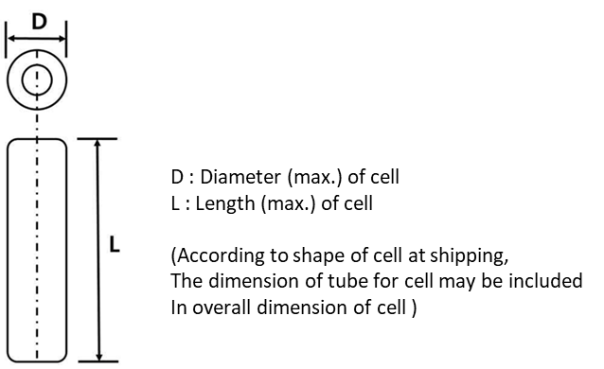  [E.3 – Cylindrical cell using hard case] |  |  | —

